Chapter 11, Solution 18.

Find the value of Z_{L} in the circuit of Fig. 11.49 for maximum power transfer.

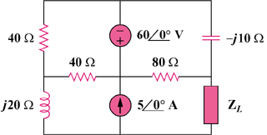

j30 Ω

Figure 11.49
For Prob. 11.18.

Solution

We find at terminals a-b as shown in the figure below.

40

-j10

80

40

j30

Z_{th}

b

a

[21.23–j20.15] Ω

